SHOT LIST

*for Eric Armstrong*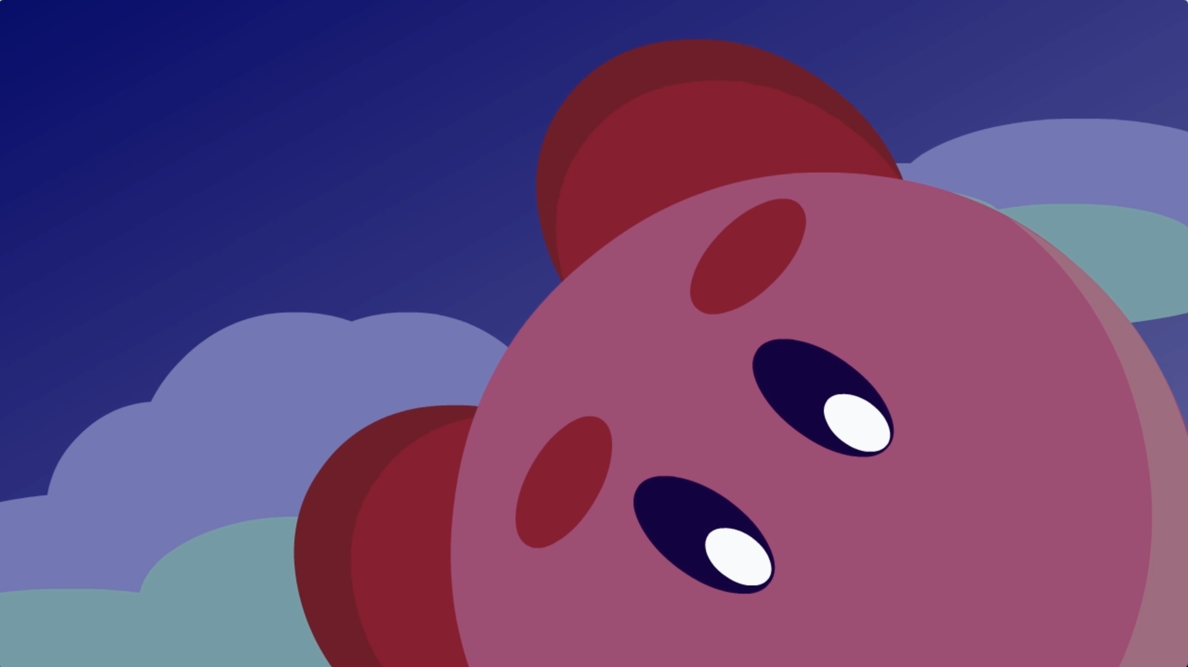

***LANDING***

Description:

A short film featuring Nintendo's video game character, Kirby, falling from the sky at a high speed; much to the surprise of some passerby. He lands on his feet near a local city leaving a crater where he stands.

Roles:

The film in its entirety was made by me. Credit for all characters depicted goes to Nintendo.

Methods:

Each element was drawn and developed using Adobe Animate.



***BUZZ***

Description:

A short film in which a small creature is intrigued by the appearance of a buzzing bug. The bug soon zips away and all seems well until an entire swarm of bugs charge forward and push the creature away.

Roles:

The film in its entirety was made by me.

Methods:

Each element was drawn and developed using Adobe Animate.

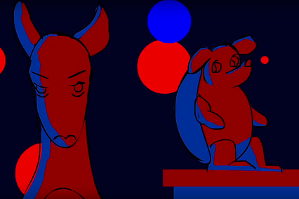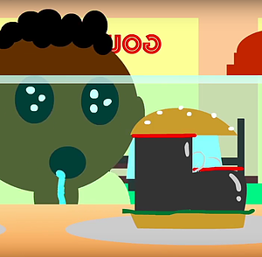***ONE SECOND ANIMATIONS***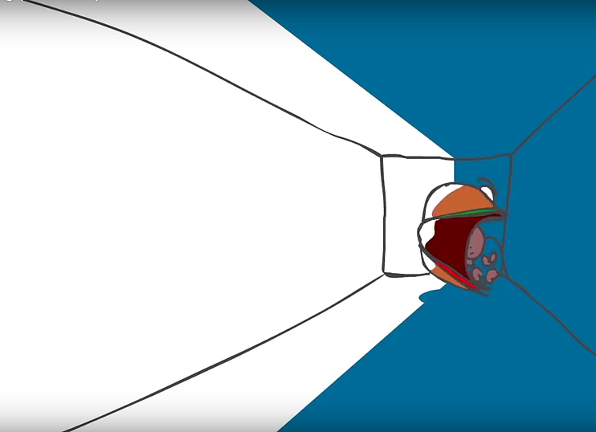

Description:

A series of one second animations I did for a project that was featured in the Victorian College of the Arts “International Animation Day” film festival in Melbourne, Australia. Each animation followed a certain theme of two or more words that (Hamburger/Fear ; Kanagaroo/Amadillo/Dance Party; Shoe/Hunger).

Roles:

Each film was made enitirely by me.

Methods:

Each animation was  drawn and developed in Adobe Animate.

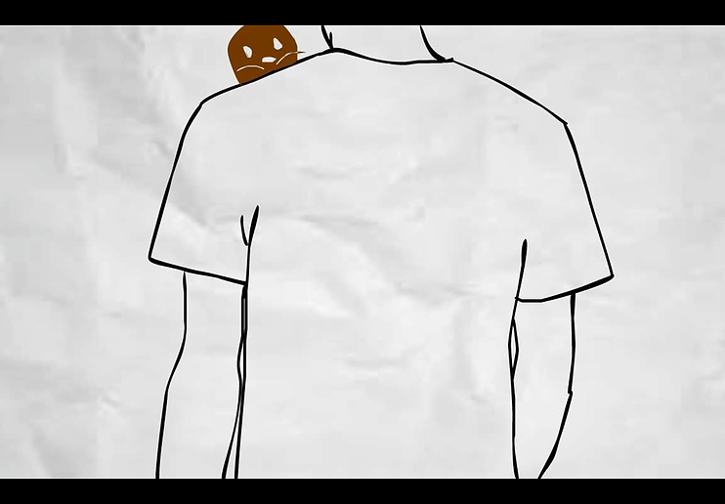

***LITTLE FRIENDS***

Description:

A film featuring tiny, curious creatures taking interest in a new human wandering through! It was featured in the national film festival “Secret Life of the Storyboard” held in Grants Pass, OR as well as received 1st prize in SHSU’s annual “Juried Show.”

Roles:

The film in its entirety was made by me.

Methods:

The walking character was rotoscoped while the tiny creatures were drawn by hand in Adobe Animate. A paper texture was used as the background in order to create a more personal feel.

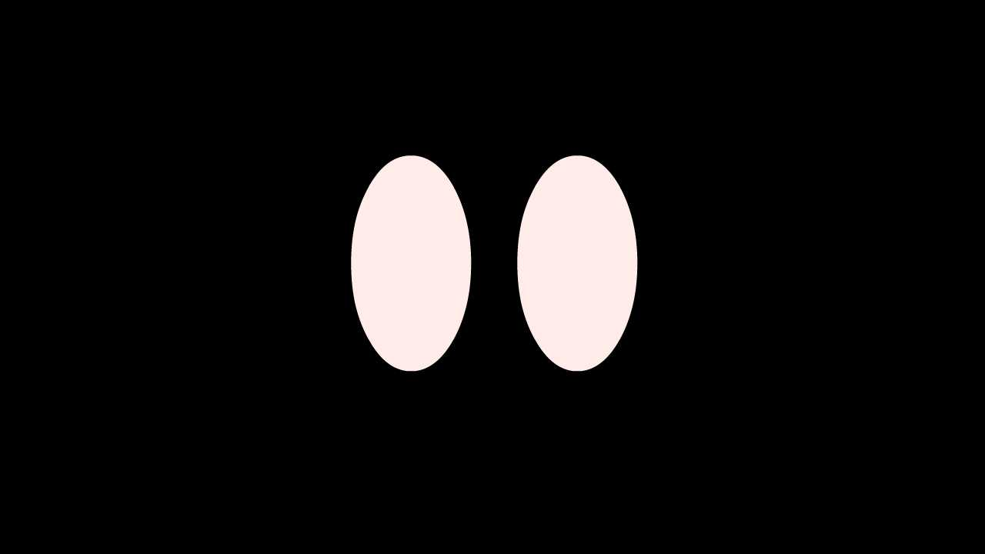

**EYES**

Description:

A pair of eyes looking around and attempting to walk away only to bump into the frame of the video and fall apart.

Roles:

This film in its entirety was made by me.

Methods:

Each element was drawn and developed using Adobe Animate.

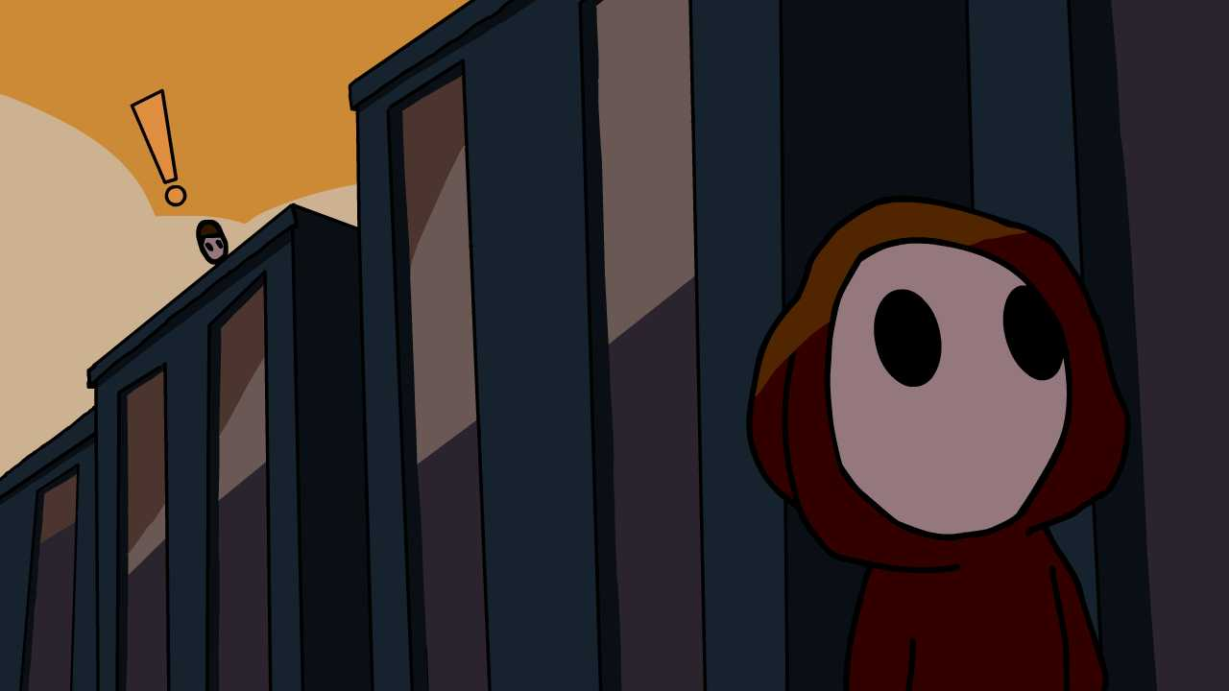

**HERO**

Description:

A local superhero takes on his greatest challenge yet. Asking his crush out!

Roles:

The film in its entirety was made by me.

Methods:

Each element was drawn and developed using Adobe Animate.

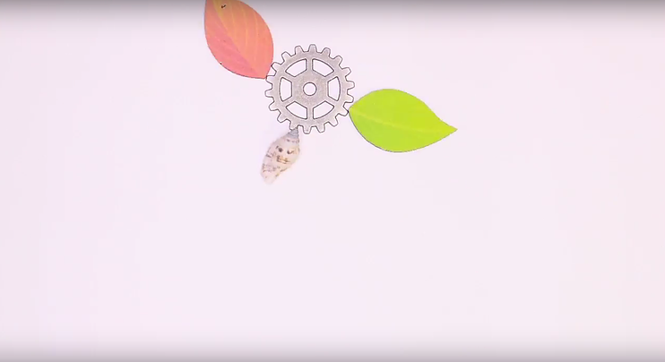

***FREEDOM***

Description:

A short stop motion film made from various and random craft items.

Roles:

The film in its entirety was made by me.

Methods:

Each element was handpicked from a wide assortment of craft items and then placed on a flat surface to be photographed by a digital camera.